# [LAW & ORDER: ORGANIZED CRIME: Bryan Goluboff Exits, Sean Jablonski to Serve as Showrunner](https://www.givememyremote.com/remote/2022/09/01/law-and-order-organized-crime-showrunner-sean-jablonski-bryan-goluboff-exits/)

September 1, 2022 by [Marisa Roffman](https://www.givememyremote.com/remote/author/marisa/)

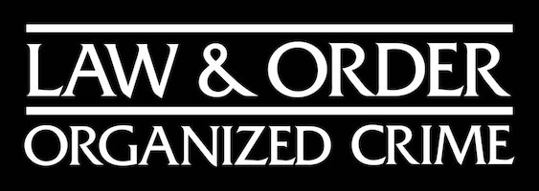

***LAW & ORDER: ORGANIZED CRIME — Pictured: “Law & Order: Organized Crime” Logo — (Photo by: NBCUniversal)***

LAW & ORDER: ORGANIZED CRIME is undergoing another behind-the-scenes change: [Bryan Goluboff](https://www.givememyremote.com/remote/2022/08/29/organized-crime-elliot-olivia-relationship-svu-bryan-goluboff/) has exited the NBC drama, and Sean Jablonski will serve as showrunner moving forward.

ORGANIZED CRIME was ordered [straight to series in 2020](https://www.givememyremote.com/remote/2020/06/16/its-official-nbc-orders-svu-spinoff-starring-christopher-meloni/), with Matt Olmstead initially set to run the show; he departed a few months later, and [Ilene Chaiken stepped in to rework and run the series](https://www.givememyremote.com/remote/2020/12/09/law-and-order-organized-crime-boss-ilene-chaiken/). [Chaiken exited in February 2022](https://www.givememyremote.com/remote/2022/02/25/law-and-order-organized-crime-ilene-chaiken-exit-barry-obrien-showrunner/), with Barry O’Brien (who was a part of the season 2 writing staff) [stepping in temporarily to showrun the end of season 2](https://www.givememyremote.com/remote/2022/02/25/law-and-order-organized-crime-ilene-chaiken-exit-barry-obrien-showrunner/). (O’Brien stayed with OC in season 3 as a writer/executive producer.)

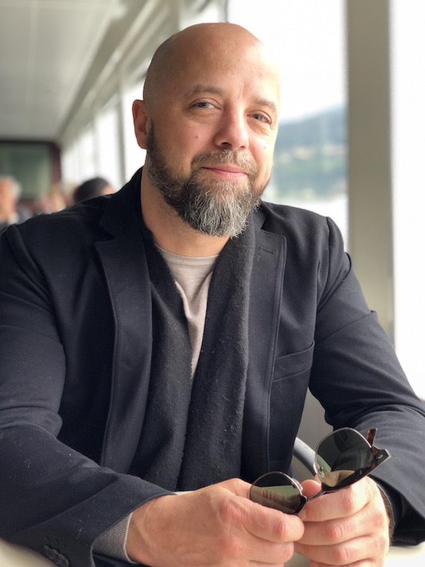

***Sean Jablonski (Photo credit: Catherine Rodriguez)***

[Goluboff joined ORGANIZED CRIME between seasons 2 and 3](https://www.givememyremote.com/remote/2022/05/26/law-and-order-organized-crime-season-3-showrunner-bryan-goluboff/), coming off a run at LAW & ORDER: SPECIAL VICTIMS UNIT. “The episode we did [on SVU] with [ORGANIZED CRIME star] Chris [Meloni]—with Gabe Navarro and the woman who was the singer in the nightclub; that whole thing with the conflict between Benson and Stabler—that was an episode where I really enjoyed being in the OC universe…the size of it and the international scope of the crimes,” [Goluboff told Give Me My Remote in August](https://www.givememyremote.com/remote/2022/08/24/law-and-order-organized-crime-season-3-spoilers-bryan-goluboff/). “It kind of hooked me into talking about OC with the Wolf [Entertainment] people, and getting an understanding of where the show could go…I enjoyed being in that universe with them. And it’s definitely sparked a lot of stuff [for me].”

Jablonski’s previous writing credits including PROJECT BLUE BOOK, NIP/TUCK, SUITS, LAW & ORDER, and OZ.

It’s a season of transition for the franchise, as LAW & ORDER added [Mehcad Brooks](https://www.givememyremote.com/remote/2022/08/26/law-and-order-detective-jalen-shaw-mehcad-brooks-rick-eid/) to its cast, LAW & ORDER: SVU set [David Graziano as its new showrunner](https://www.givememyremote.com/remote/2022/06/01/law-and-order-svu-season-24-showrunner-david-graziano/) and [long-time co-star Kelli Giddish will exit during the upcoming season](https://www.givememyremote.com/remote/2022/08/24/law-and-order-svu-kelli-giddish-exit-season-24/). The LAW & ORDERs will also have a franchise-first [three-show crossover](https://www.givememyremote.com/remote/2022/08/24/law-and-order-svu-organized-crime-crossover-event/) to kick off the season on Thursday, September 22.

Season 3 of ORGANIZED CRIME stars Meloni, Danielle Moné Truitt, Ainsley Seiger, Brent Antonello, and Rick Gonzalez star. Dick Wolf, Jablonski, Goluboff, O’Brien, John Polson, Paul Cabbad, Arthur Forney, Meloni, and Peter Jankowski serve as executive producers.

* [NBC Reveals LAW & ORDER Crossover Key Art](https://www.givememyremote.com/remote/2022/09/01/law-and-order-crossover-poster/)
* [Bryan Goluboff Teases How LAW & ORDER: ORGANIZED CRIME and SVU Will Dive Into Elliot and Olivia’s Time Apart—and Previews Their Future](https://www.givememyremote.com/remote/2022/08/29/organized-crime-elliot-olivia-relationship-svu-bryan-goluboff/)
* [LAW & ORDER: ORGANIZED CRIME is Shaking Up Its Format in Season 3](https://www.givememyremote.com/remote/2022/08/24/law-and-order-organized-crime-season-3-spoilers-bryan-goluboff/)
* [Behind-the-Scenes Photos and Videos from the LAW & ORDER Franchise Crossover](https://www.givememyremote.com/remote/2022/08/24/behind-the-scenes-photos-and-videos-from-the-law-order-franchise-crossover/)
* [NBC Confirms LAW & ORDER Crossover Event With New Promo](https://www.givememyremote.com/remote/2022/08/24/law-and-order-svu-organized-crime-crossover-event/)
* [LAW & ORDER: ORGANIZED CRIME Adds Gus Halper and Camilla Belle](https://www.givememyremote.com/remote/2022/08/12/law-order-organized-crime-gus-halper-camilla-belle/)
* [LAW & ORDER: ORGANIZED CRIME Adds Rick Gonzalez and Brent Antonello](https://www.givememyremote.com/remote/2022/07/29/law-and-order-organized-crime-season-3-cast-rick-gonzalez-brent-antonello-nona-parker-johnson/)
* [6 Dream LAW & ORDER Franchise Crossover Pairings](https://www.givememyremote.com/remote/2022/07/14/6-dream-law-and-order-franchise-crossover-pairings/)
* [NBC Eyes LAW & ORDER-SVU-ORGANIZED CRIME Crossover Event](https://www.givememyremote.com/remote/2022/07/06/law-and-order-cross-ver-svu-organized-crime-nbc/)
* [LAW & ORDER: ORGANIZED CRIME Sets Bryan Goluboff as Showrunner](https://www.givememyremote.com/remote/2022/05/26/law-and-order-organized-crime-season-3-showrunner-bryan-goluboff/)
* [LAW & ORDER: ORGANIZED CRIME Season 2 Finale Recap: Elliot’s Latest Undercover Mission Comes to an End](https://www.givememyremote.com/remote/2022/05/19/law-order-organized-crime-season-2-finale-recap/)
* [NBC Renews LAW & ORDER and LAW & ORDER: ORGANIZED CRIME](https://www.givememyremote.com/remote/2022/05/10/nbc-renews-law-order-and-law-order-organized-crime-season-3/)
* [LAW & ORDER: ORGANIZED CRIME Post-Mortem: Octavio Pisano on the Importance of Benson’s ‘Vote of Confidence’](https://www.givememyremote.com/remote/2022/05/05/law-order-organized-crime-lost-one-spoilers-octavio-pisano/)
* [LAW & ORDER: ORGANIZED CRIME: ‘Lost One’ Photos](https://www.givememyremote.com/remote/2022/05/05/law-order-organized-crime-lost-one-photos/)
* [LAW & ORDER: SPECIAL VICTIMS UNIT Star Octavio Pisano Previews His Guest Spot on ORGANIZED CRIME](https://www.givememyremote.com/remote/2022/05/04/law-and-order-special-victims-unit-star-octavio-pisano-organized-crime/)
* [LAW & ORDER: ORGANIZED CRIME Post-Mortem: Mykelti Williamson on Webb and Stabler’s New Alliance](https://www.givememyremote.com/remote/2022/04/14/law-and-order-organized-crime-webb-stabler-alliance/)
* [LAW & ORDER: ORGANIZED CRIME’s Mykelti Williamson on the ‘Bonnie and Clyde Meets Robin Hood’ Webb Family, Plus the Dueling ‘Ticking Clock’ Threats](https://www.givememyremote.com/remote/2022/04/13/law-and-order-organized-crime-mykelti-williamson-interview-preston-webb/)
* [LAW & ORDER: ORGANIZED CRIME Post-Mortem: Dann Florek Breaks Down Cragen and Stabler’s Reunion](https://www.givememyremote.com/remote/2022/04/07/law-and-order-organized-crime-dann-florek-cragen/)
* [LAW & ORDER: ORGANIZED CRIME: Nona Parker Johnson Previews Nova’s Collision with the Brotherhood](https://www.givememyremote.com/remote/2022/04/07/law-and-order-organized-crime-nova-brotherhood-nona-parker-johnson/)
* [LAW & ORDER: ORGANIZED CRIME’s Dann Florek Teases Cragen’s Return: ‘It’s Part History and Part Mystery’](https://www.givememyremote.com/remote/2022/04/06/law-and-order-organized-crime-cragen-return-dann-florek-interview/)
* [LAW & ORDER: ORGANIZED CRIME Post-Mortem: Nona Parker Johnson Breaks Down Nova’s Shift in ‘Guns & Roses’](https://www.givememyremote.com/remote/2022/03/17/law-and-order-organized-crime-nova-hugo-webb-nona-parker-johnson-interivew/)
* [LAW & ORDER: ORGANIZED CRIME’s Nona Parker Johnson Teases Nova Split Undercover Loyalty](https://www.givememyremote.com/remote/2022/03/16/law-and-order-organized-crime-nova-nona-parker-johnson-interview/)
* [LAW & ORDER: ORGANIZED CRIME Recap: The Wheatley Arc Comes to an End](https://www.givememyremote.com/remote/2022/03/03/law-and-order-organized-crime-richard-wheatley-dies-angela/)
* [LAW & ORDER: ORGANIZED CRIME: Tamara Taylor on Angela’s Drive to Protect Her Children](https://www.givememyremote.com/remote/2022/02/18/law-and-order-organized-crime-angela-wheatley-motherhood-tamara-taylor/)
* [LAW & ORDER: ORGANIZED CRIME Post-Mortem: Tamara Taylor Breaks Down Angela and Richard’s Messy Dynamic](https://www.givememyremote.com/remote/2022/01/20/law-order-organized-crime-angela-richard-reunite-tamara-taylor-interview/)
* [LAW & ORDER: ORGANIZED CRIME Post-Mortem: Tamara Taylor and Robin Lord Taylor Break Down Angela and McClane’s New Connection](https://www.givememyremote.com/remote/2022/01/13/law-and-order-organized-crime-mcclane-angela-tamara-taylor-robin-lord-taylor/)
* [LAW & ORDER: ORGANIZED CRIME: Tamara Taylor on Angela (Accidentally) Blowing Her Cover](https://www.givememyremote.com/remote/2022/01/13/law-and-order-organized-crime-angela-wheatley-tamara-taylor-interview/)
* [LAW & ORDER: ORGANIZED CRIME: Robin Lord Taylor Previews McClane’s Complex Relationship with the Wheatleys](https://www.givememyremote.com/remote/2022/01/12/law-and-order-organized-crime-robin-lord-taylor-mcclane-wheatlys/)
* [LAW & ORDER: SPECIAL VICTIMS UNIT’s Peter Scanavino on Filming the Massive Crossover with OC, and the Case That ‘Outrages’ Carisi](https://www.givememyremote.com/remote/2021/12/16/law-and-order-svu-peter-scanavino-interview-crossover-spoilers/)
* [LAW & ORDER: ORGANIZED CRIME: Ilene Chaiken Teases a ‘Very Christmas-y’ Crossover Hour, Stabler Family Drama](https://www.givememyremote.com/remote/2021/11/24/law-and-order-organized-crime-christmas-episode-spoilers/)
* [LAW & ORDER: ORGANIZED CRIME’s Danielle Moné Truitt and Ilene Chaiken Preview Bell’s Career Ambitions, New Dynamic with Brewster](https://www.givememyremote.com/remote/2021/11/18/law-and-order-organized-crime-promotions-danielle-mone-truitt-ilene-chaiken-bell-brewster-stabler/)
* [LAW & ORDER: ORGANIZED CRIME Post-Mortem: The Team Breaks Down ‘Ashes to Ashes’ and What Didn’t Make the Cut](https://www.givememyremote.com/remote/2021/11/11/law-and-order-organized-crime-ashes-to-ashes-spoilers/)
* [NBC Boss Teases Potential LAW & ORDER and ONE CHICAGO Crossovers](https://www.givememyremote.com/remote/2021/11/12/law-and-order-one-chicago-crossover-2022/)
* [LAW & ORDER Stars Mariska Hargitay and Christopher Meloni Weigh in on a Potential Benson/Stabler Relationship: ‘It Just Has to be Earned’](https://www.givememyremote.com/remote/2021/06/04/svu-organized-crime-benson-stabler-romance-mariska-hargitay-christopher-meloni/)
* [LAW & ORDER: ORGANIZED CRIME: Danielle Moné Truitt and Tamara Taylor Reflect on Their Favorite Season 1 Scenes](https://www.givememyremote.com/remote/2021/09/02/organized-crime-favorite-scenes-season-1-danielle-mone-truitt-tamara-taylor/)